**Assignment (Week7)**

Student Id: 30683017

Student Name: Mingxin Lyu

1. The metric I chose from the data is Q7 (Number).

2. Script:

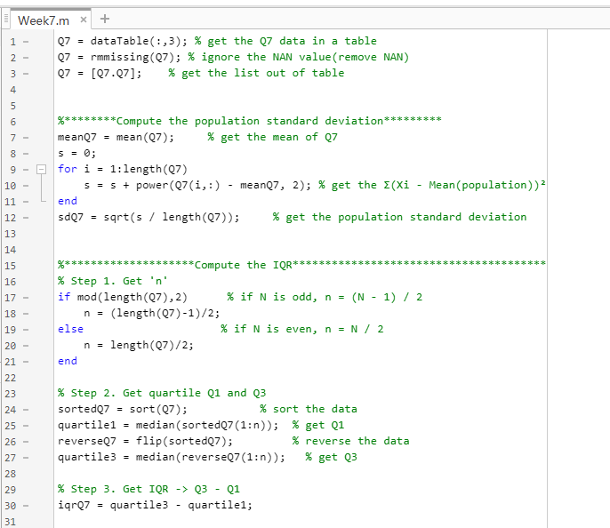

Figure 1. The script of PSD and IQR.

Results:

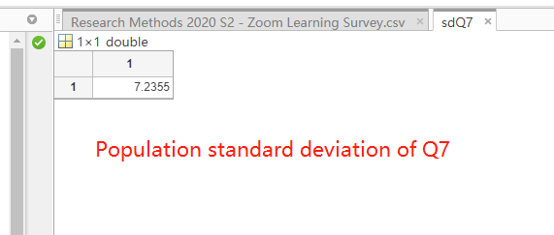

Figure 2. The result of PSD.

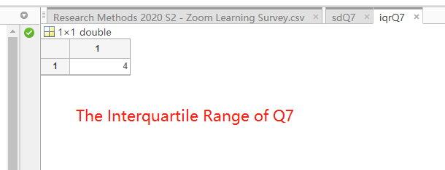

Figure 3. The result of IQR.

3. Script:

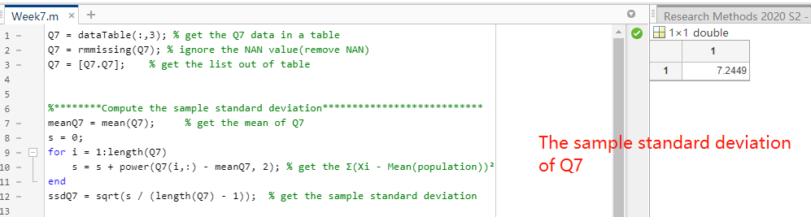

Figure 4. The script and result of SSD.

4. Script:

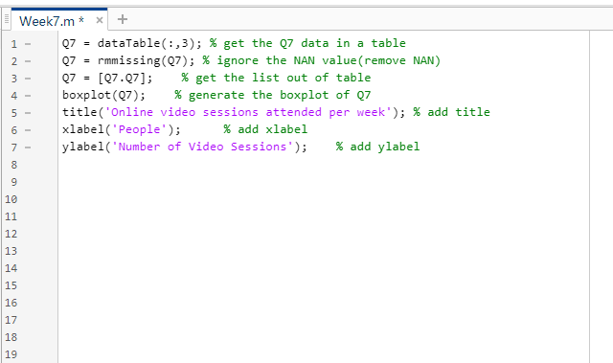

Figure 5. The script of boxplot.

Graph:

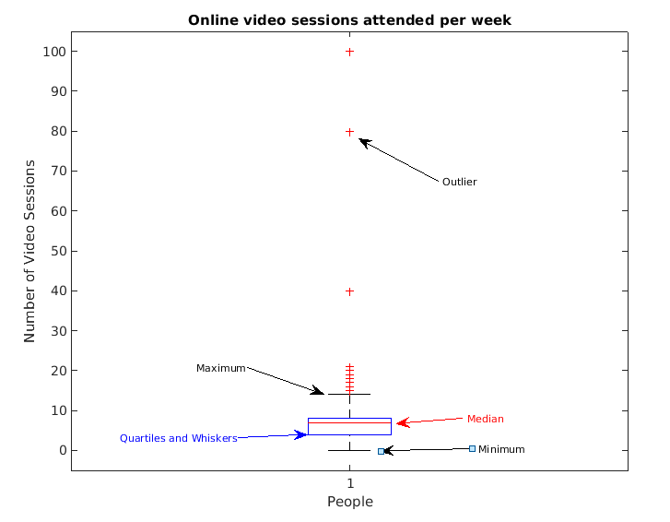

Figure 6. The graph of boxplot.